Link for simulation:
https://www.tinkercad.com/things/gF72qqGqTVD-automatic-object-sorting-system
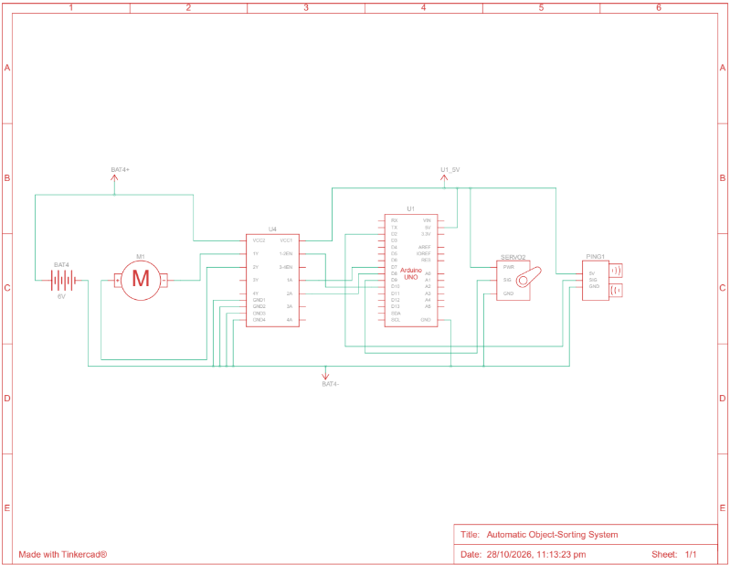
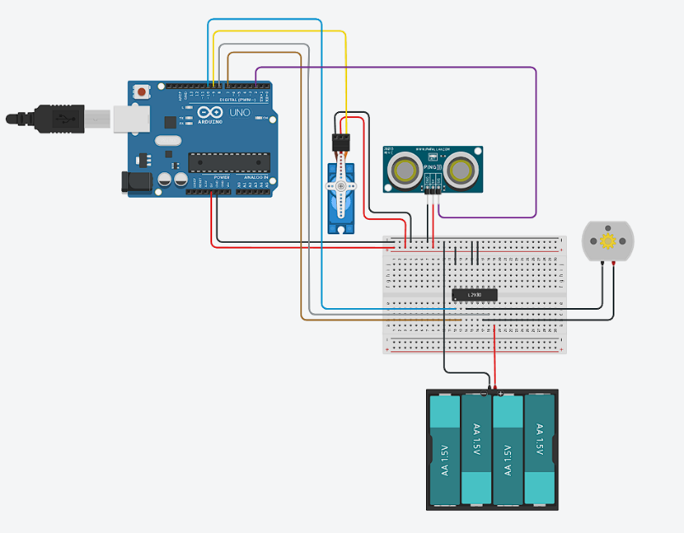
Screenshots:
Further Applications:
- E-Commerce Package Sorting:
Improved and more sophisticated algorithms can be used to sort the packages into specific chutes based on their size.
- Manufacturing and Quality Control:
Sensors check an object’s length or dimensions. If a part is too short, too long, or defective, it can be separated from other correctly-sized parts.
- Recycling and Waste Management:
According to size, waste materials can be segregated.

